

TERESA Project:

TEchnology for Rural Electrification in Sub-Saharan Africa



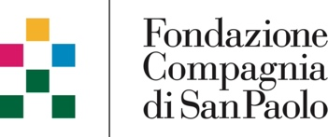

# Politecnico di Milano 1863

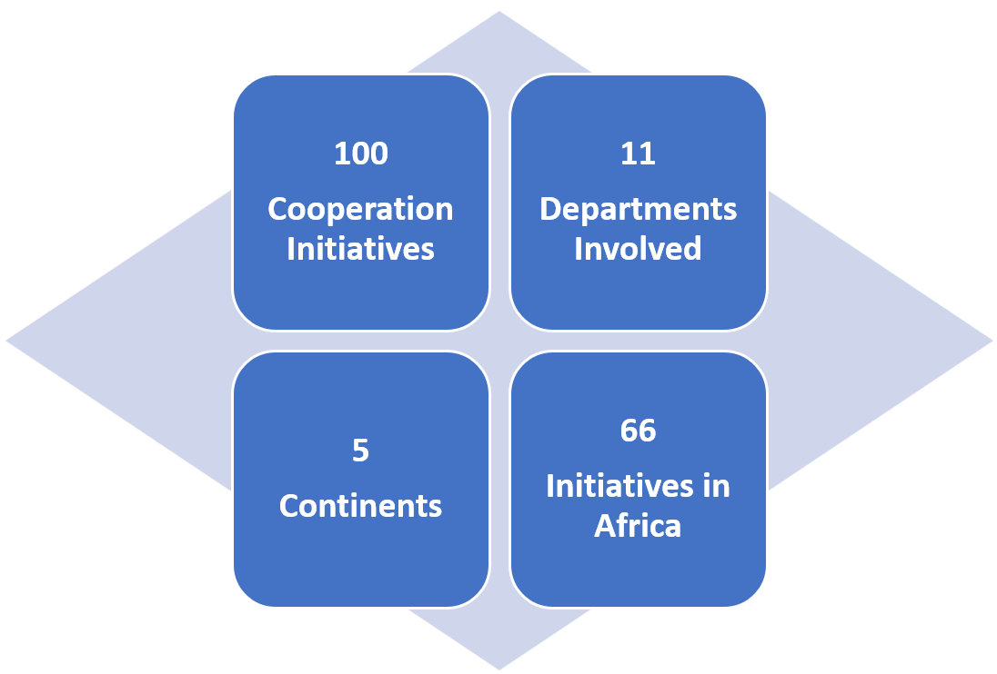Established in 1863, Politecnico di Milano is one of Europe's most outstanding technical universities, and the largest Italian university in Engineering, Architecture and Design, with over 47,500 students. The university has seven campuses in Milan and other nearby Italian cities: Lecco, Cremona, Mantova and Piacenza. It is organized in 12 Departments and in 4 Schools, respectively devoted to research and education. **Since 2005**, POLIMI has embraced its vocation for **Academic Cooperation**, starting from a characterization linked to the interest and commitment of individual professors who have been able to lay solid foundations to build a more inclusive institutional interest and participation. The number of projects involved researchers and partners has been growing in the last two decades and Polimi’s strategy now aligns with the international frameworks. In the most recent years academic institutions can play a stronger role on the international arena with specific reference to developing regions for scaling up education and scientific research asset to support local development.

Specifically, **Energy for Growing (E4G)** is an initiative of a research group of the Energy Department of ***Politecnico di Milano.*** The group studies innovative energy approaches, devoted to improving sustainability and efficiency in **electric energy management**. One of the main focuses is on on-grid and off-grid solutions for the electrification of rural areas in developing countries. Energy Storage solutions, Energy Communities, and energy market’s structure are also investigated.

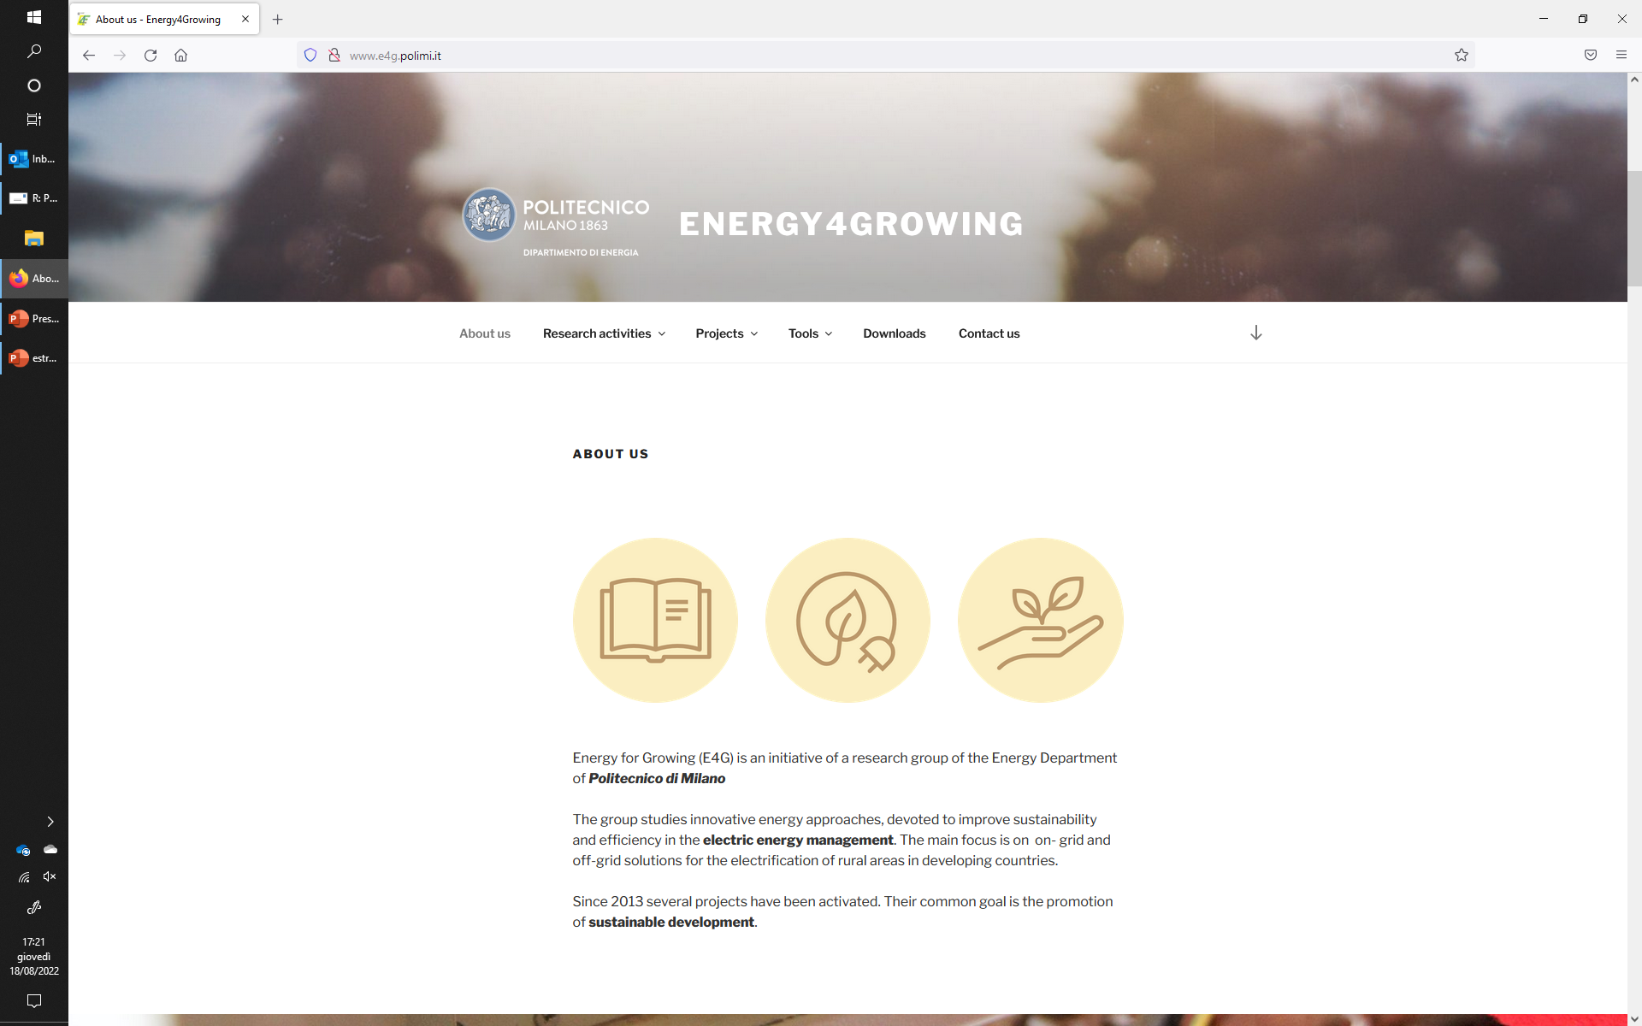

# ICEI

ICEI is an Italian NGO founded in 1977 that carries out cooperation interventions in Italy and around the world, working with people and local communities to improve social and economic conditions and promote inclusive, fair, and sustainable societies in a participatory way. ICEI is active in different countries with more than 20 active projects and 15.700 beneficiaries. ICEI works with people and local communities to improve social and economic conditions and promote inclusive, fair and sustainable societies in a participatory manner. The priority targets, across all areas, are the most vulnerable, with a special focus on young people and women. Since 2011 ICEI operates in Mozambique with a sustainable rural development program that includes agricultural and environmental projects carried out in the provinces of Nampula, Zambezia and Maputo. Here are the four main sectors in which ICEI operates.

**Responsible Tourism** - Promote local economic development alongside the valorization of natural resources as well as artistic and cultural heritage; Fight poverty and create employment in the framework of community-based tourism initiatives; Contribute to reconverting the tourism industry to practices based on sustainability and social responsibility.

**Intercultural Citizenship -** Promote the ability of citizens to strengthen their interactions by building bridges between cultures and blending diversity to build trust and cohesive communities, facilitate access to and protection of rights and provide new opportunities.

**Sustainable Agriculture** - Ensure food security and promote sustainable and climate resilient agriculture; Promote inclusive, and sustainable economic growth; Ensure sustainable production and consumption patterns; Promote ecological trends in agriculture; Support to agricultural research.

**Work Inclusion** - Promote employability, prevent exclusion, and ensure equal access of people to the labor market, including entrepreneurship as a form of self-employment, in particular by supporting the integration into employment of the most disadvantaged people and groups (migrants, young women).

# Contents

Politecnico di Milano 1863 iii

ICEI v

Contents 7

1 Introduction 9

1.1. The Project: TERESA 9

2 Methodology 11

2.1. Communities Identification 11

2.2. Estimation of the Zambezia energy map 13

2.2.1. On-field surveys 15

2.2.2. Energy map 17

2.3. Electrification masterplan 20

3 Future improvement and Follow-ups 23

Annex 1 - Acronyms 25

Annex 2 - User Friendly Dashboard 27

Surveyed 28

Surveyed: Entire Area 28

Surveyed: Single Cluster 29

Surveyed: Compare clusters 31

Zambezia visualization 31

Zambezia visualization: Entire area 31

# Introduction

One of the foundational elements of human development is access to energy. The United Nations has adopted the objective of having affordable, reliable, and sustainable energy as the 7th goal of the 2030 Agenda for Sustainable Development across the world, which has increased attention to this topic substantially in recent years. Goal 7 comprises five targets: two of them are "means of accomplishing target," while the other three are "outcome targets".

7.2 Increase percentage of renewable energy

7.1 Universal access to modern energy

7.3 Double the improvement in energy efficiency

Expand energy services for developing countries

energy

Promote access to research and investments

The "Energy Progress Report" shows that access to power has dramatically risen over the past decade. However, the Covid-19 pandemic reversed the positive trend in energy access, causing the first regression since 2013. Up to today, 660 million people are without reliable electricity (most of whom are in Sub-Saharan Africa). In this context, it is widely recognized that energy does not represent only a goal but a pillar in guaranteeing the quality of livelihoods and a key element in development: an enabler of socio-economic development, capable of leading to direct improvements in multiple social dimensions and improving the quality of life. In 2020, Sub-Saharan Africa's portion of the global population without access to electricity was 77% with a significant disparity in electrification rates between urban and rural communities in this region, with the former at 78.3% and the latter at 28.7%. In order to face this challenge a comprehensive approach must be undertaken, in which several significant issues must be addressed: 1. Lack of accurate data; 2 Physical Constraints, e.g., those correlated to inaccessible villages; 3. Social constraints such as people’s awareness and acceptance of the new situation.

## The Project: TERESA

The TERESA project is funded by Technologies for Sustainable Development 2021 – Program of Fondazione Cariplo and Fondazione Compagnia di San Paolo. It aims at contributing to ensuring universal access to affordable, reliable, and modern energy services in Mozambique, in line with SDG 7 “Accessible and clean energy”, through promoting innovation in the field of international development cooperation (open innovation/challenges, training, events/networking). TERESA project has been carried out between January 2022 and June 2023. In particular, it contributes to “guarantee universal access to affordable, reliable, and modern energy services “and to” strengthen international cooperation to facilitate access to research and clean energy technology “. Indeed, the objective is to strengthen existing tools devoted to evaluating the best electrification strategies and adopt them to develop an electrification master plan for the Zambezia province of Mozambique. The tool and the master plan will be shared open source with local and international stakeholders.

**General objective:** Design and implementation of data-driven, replicable, and scalable strategies for accessing energy in rural context, through a participatory approach thanks to expertise and network with local communities. **Open access modelling code, Identification of the optimal electricity solution, Design of the distribution network, Comprehensive model**

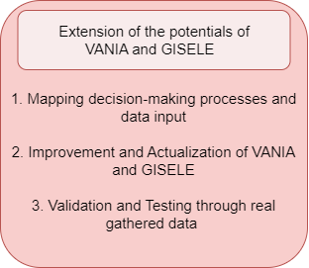 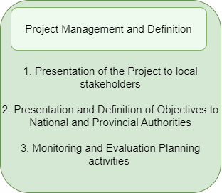 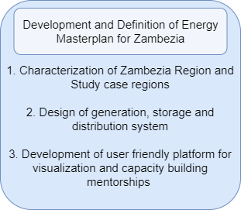

A multidimensional master plan will be carried out in the Zambezia Region; out of the ten provinces in Mozambique, this is the one with the highest number of people without access to electricity.



Zambezia Region, Mozambique

March 2022 – May 2023

ICEI; Politecnico di Milano – Energy Department; FUNAE

Collaborations and interactions: ENGreen – USAID – Power Africa; ESRI; EDM; GIZ

Zambezia Community; Policy

makers; Stakeholders

Cariplo Foundation and Compagnia di San Paolo Foundation

Zambezia is located in the central coastal region with a population of 5.11 million, it is the second most populated province and the least electrified. The lack of affordable energy access in Zambezia has significant social and economic impacts. Without access to electricity, households are forced to rely on expensive and often unreliable sources of energy such as kerosene lamps or candles. This can result in increased health risks due to indoor air pollution, limited educational opportunities, and reduced economic opportunities and small businesses that cannot operate beyond daylight hours.

# Methodology

This short report aims to introduce the steps of the procedure adopted for the definition of the best electrification strategy. In particular, the proposed procedure consists of three main steps (as depicted in figure 1). In the following chapter, each one of those steps is shortly introduced.

Preliminary energy master plan

Identification and characterization of communities

Estimation of the energy map of Zambezia

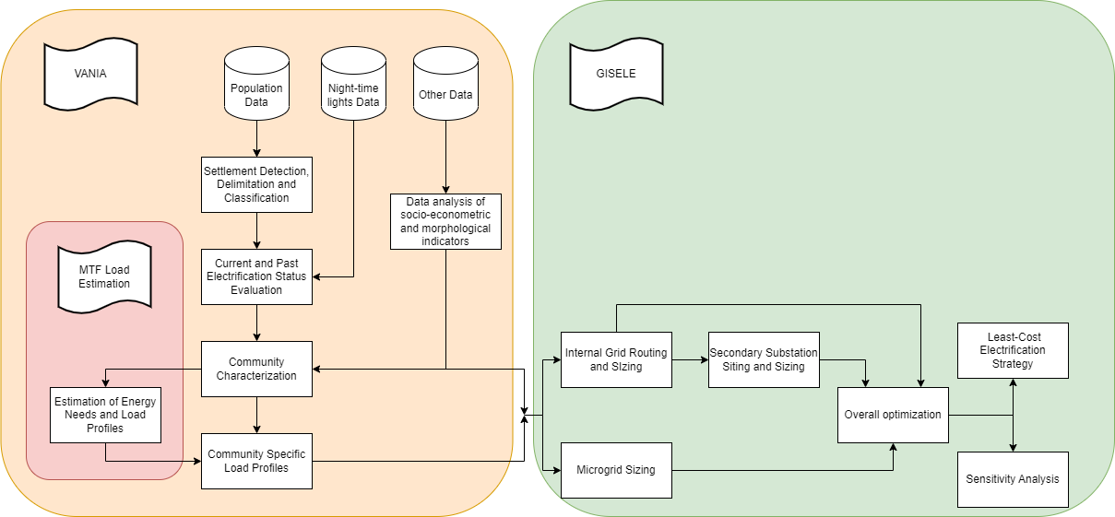

*Figure 1. Flow chart of the proposed procedure*

## Communities Identification

One of the major problems in developing countries, is the lack of reliable and accurate data. In order to overcome this problem, the TERESA project has been based on public GIS datasets and as detailed in the following, on an on-field campaign of interviews and surveys, devoted to validating and integrating such datasets.

In order to identify the communities in place, a tool named VANIA has been adopted. It is designed to gather socio-econometric information and to correlate them to specific cluster. In particular VANIA is in charge to:

1. Locate all the communities in the area under investigation;
2. Classify those communities among electrified and not electrified;
3. Processes currently available open-source datasets to perform socio-economic parametrization of the communities.

The clustering procedure utilizes an iterative implementation of DBScan, a density-based algorithm. The current version of the tool defines the communities' borders based on the building distribution and on population density. Once the boundaries of each community are defined, the procedure attributes multiple parameters for characterizing each cluster through economic, social, environmental, and infrastructural information (as detailed in table 1).

*Table 1. Name and source of considered data-set*

|  |  |  |  |
| --- | --- | --- | --- |
| Name | Source | Name | Source |
| Administrative | [UN Agencies](https://data.humdata.org/) | Networks | [World Bank](https://datacatalog.worldbank.org/dataset/africa-electricity-transmission-and-distribution-grid-map-2017) |
| Cell towers | [OpenCell](https://opencellid.org/) | Night Lights | [NASA](https://earthobservatory.nasa.gov/features/NightLights) |
| Clustering (Sub) | [KTH](https://data.mendeley.com/datasets/z9zfhzk8cr/6) | Population | [Facebook](https://data.humdata.org/search?q=hrsl&ext_search_source=main-nav) |
| Crops | [Harvard](https://dataverse.harvard.edu/dataset.xhtml?persistentId=doi:10.7910/DVN/FSSKBW) | Population Growth | [Columbia](https://sedac.ciesin.columbia.edu/data/set/popdynamics-1-8th-pop-base-year-projection-ssp-2000-2100-rev01/docs) |
| Development Potential | [Columbia](https://sedac.ciesin.columbia.edu/data/set/lulc-global-grid-prob-urban-expansion-2030/data-download) | Poverty | [WorldPop](https://www.worldpop.org/geodata/summary?id=1267) |
| Distance to city | - | Protected areas | [Protected Planet](https://www.protectedplanet.net/en/search-areas?geo_type=country) |
| Elevation | [RCMRD](https://hub.arcgis.com/search?q=srtm%20dem) | Relative Wealth | [Facebook](https://data.humdata.org/dataset/relative-wealth-index) |
| Food Insecurity | [Columbia](https://sedac.ciesin.columbia.edu/data/set/food-food-insecurity-hotspots) | Rivers | [Hydroshed](https://www.hydrosheds.org/) |
| GHI | [Global Solar Atlas](https://globalsolaratlas.info/download/burkina-faso) | Roads | OSM |
| HDI | [UN](https://globaldatalab.org/shdi/shapefiles/) | Schools | OSM |
| Hospitals | [OCHA](https://data.humdata.org/search?q=healthsites&ext_search_source=main-nav) | Substations | Multiple |
| Landcover | [ESA](http://2016africalandcover20m.esrin.esa.int/download.php) | Urban percentage | [WorldPop](https://wopr.worldpop.org/?/Buildings) |
| Literacy | [WorldPop](https://www.worldpop.org/geodata/summary?id=1266) | Wind | [Global Wind Atlas](https://globalwindatlas.info/downloads/gis-files) |
| Locations | [OpenStreetMap](https://download.geofabrik.de/africa.html) | MTF | [World Bank](https://energydata.info/dataset?q=Multi-Tier+Framework+%28MTF%29+Survey&sort=score+desc%2C+metadata_modified+desc) |

Finally, communities are classified among electrified and not electrified thanks to an algorithm (see figure 2) that processes the electric grid datasets and the nighttime lighting dataset. The latter is based on a global database[1] reporting nighttime light, with a spatial resolution of 1 km and temporal resolution of one year, from 1992 to 2018.

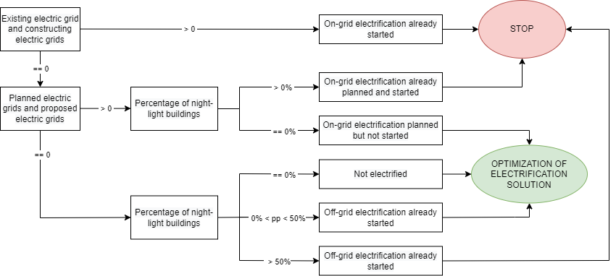

*Figure 2. Definition of electrification status and type procedure*

## Estimation of the Zambezia energy map

Load profile estimation is critical for planning rural electrification; it is essential for determining the energy system’s capacity and selecting the best approach for electrification. The proposed procedure classifies consumers in different user classes, which refer to different appliances and time-usage. The daily electric energy consumption could be calculated by knowing the appliance’s power and functioning time. The household's energy load profile is then added to other layers (each one reporting energy needs), such as commercial activities and public buildings. In the proposed approach, all the activities and their energy needs are grouped into different classes based on their behavior. Through this approach it is possible to create an energy density map for each cluster. The overall procedure and the different layers of the energy density map are summarized in the following.

*Figure 3. Flowchart of the procedure in charge to quantify the energy map of the area under investigation*

* Households: ESMAP launched MTF program to collect comprehensive data about energy access. The Framework provides a methodology for measuring access in a tiered spectrum – from Tier 0 (no access) to Tier 5 (the highest level of access). Thus, the captured data could allow a better understanding of energy access gaps and develop a potential solution for improvement. This study uses a criterion of 5% of a household's income and expenditure to classify households into tiers. In this layer, there are five tiers of households based on their appliance ownership. As reported in *Table 2*, for each tier, there is detailed information about appliances and usage windows.

*Table 2. Tiers, usage windows and appliances*



* Education Centers: all the education centers, such as schools, universities, institutions, etc., are included in a dedicated layer. Due to the lack of reliable sources, it’s hard to properly process data belonging to this layer.
* Health Centers: the system consists of three levels of health services and hospitals, classified with respect to the served population. A list of electrical appliances was estimated for each health center, and consequently, the energy needs have been estimated.

Table 3. Tiered based health services (HSDP with WHO)

|  |  |
| --- | --- |
| Type | Served population |
| Health post | 3.000 – 5.000 |
| Health centre I | 15.000 – 25.000 |
| Health centre II | 25.000 – 40.000 |
| General Hospital | 40.000 – 100.000 |

* Other: For what concern the shops energy needs, the authors refer to JICA energy masterplan that defines the loads for ten different communities. Through this it has been possible to calculate hourly key-factors used to compute each community's final shop load demand.

Once all the above layers were analyzed and computed, it is possible to compute each community's energy load profile and peak power. It must be noted that the loads are based on MTF approach, i.e. it is correlated with the household's income.

### On-field surveys

In order to validate and integrate public datasets, an extended on-filed campaign has been set up. To facilitate the gathering of data, a comprehensive list of communities in which there are active or closed project with the local partner has been analyzed and among them different communities have been chosen: at the end 726 surveys have been done. In the following table the list of the communities that have been surveyed with the key factors is reported.

Table 4. List of surveyed communities

|  |  |  |  |  |
| --- | --- | --- | --- | --- |
| Type | Served population | Latitude | Longitude | Number of surveys |
| Quelimane | Navilembo | -17,65° | 36,69° | **63** |
| Quelimane | Mucor | -17,80° | 37,01° | **67** |
| Nicoadala | Mucelo novo | -17,62° | 36,76° | **70** |
| Nicoadala | 25 de junho | -17,58° | 36,70° | **64** |
| Namacurra | Muebele | -17,62° | 37,14° | **133** |
| Mocubela | Gurai | -17.31° | 37.97° | **72** |
| Maganja da costa | Mussaia | -17,41° | 37,35° | **65** |
| Namacurra | Mazuau | -17,69° | 37,24° | **113** |
| Maganja da costa | Masqueira | -17,55° | 37,46° | **79** |

|  |  |
| --- | --- |
| *Figure 4. Population and gender of different surveyed communities* |   *Figure 5. Share of survey performed in the different communities* |

The surveys have been carried out through local enumerators with experience in data gathering and capacity building, fastening the data acquisition and improving the reliability of the acquired data, thanks to relationships with local communities they built in previous projects. Though the survey was possible to analyze the income, the expenditure, and the willingness to pay of the households, as well as information about the appliances, the outages, and others. Results clearly point out a correlation between the income and the expenditure, while no direct links result for the income and the willingness to pay.

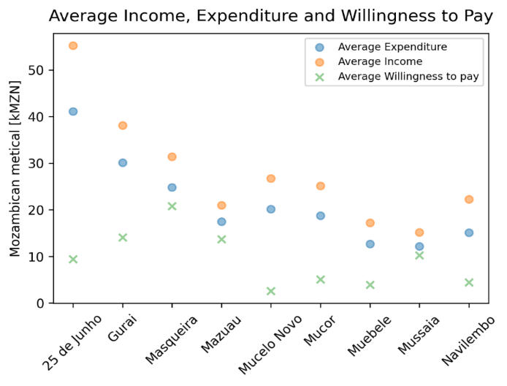

*Figure 6. Comparison between income, expenditure, and willingness to pay.*

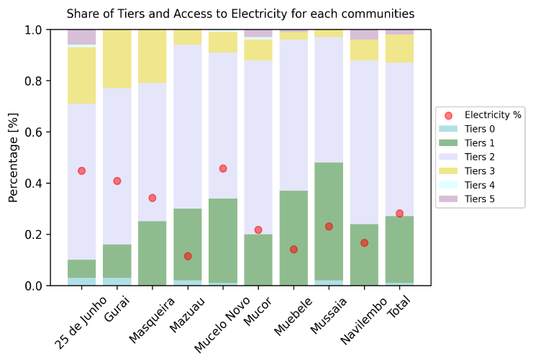

*Figure 7. Comparison between share of tiers and electrification ratio*

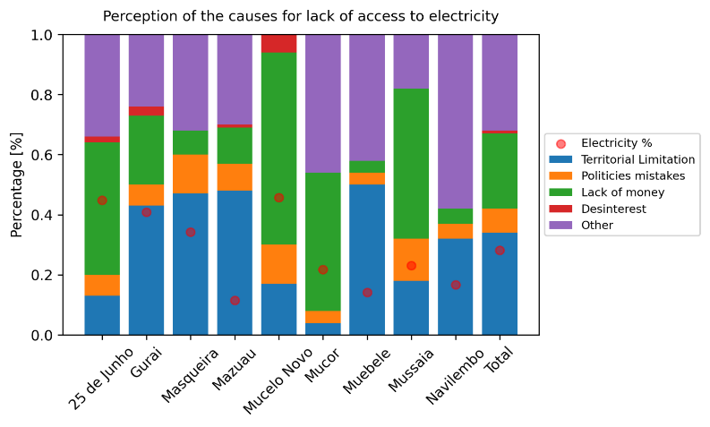

*Figure 8. Perception of the causes for lack of electricity*

Moreover, the usage of electricity in economic activities has been investigated. Focusing on the partially electrified communities, only the 5.5% of surveyed working people use electricity to generate income. Figure 7 and Figure 8 draw attention to an interesting and thought-provoking observation: the electrification ratio consistently falls short of the 50% mark, with the lowest values nearing 10%. This striking statistic prompts further analysis by examining the division into tiers: the majority of the population resides in Tier 1 and Tier 2, indicating a higher likelihood of electrification and implying that a significant proportion of individuals in these areas could enjoy the benefits of basic appliances, such as phones and lights. However, the relatively lower percentage of electrification in Tier 3 regions sheds light on the complex challenges a considerable portion of the population faces. These challenges encompass not only financial constraints (theoretically less critical for Tier 3 people) but also territorial limitations that bounds access to a reliable electricity provision. These findings pointed out the multifaceted factors contributing to the disparities in electrification rates across different tiers. Territorial limitations, i.e. geographical barriers or remote locations that make it challenging to deploy power infrastructure, play a not minor role. On the other hand, the lack of financial resources may restrict individuals to access and utilize electricity. Hence, only the 30% of people declared to have access to reliable electricity.

In particular, in the investigated rural areas the costs of national grid deployment are a barrier to electrification, motivating the vast usage of solar home system (this is for approx. 50% of the surveys), while there is a very poor share of microgrids (see figure 8).

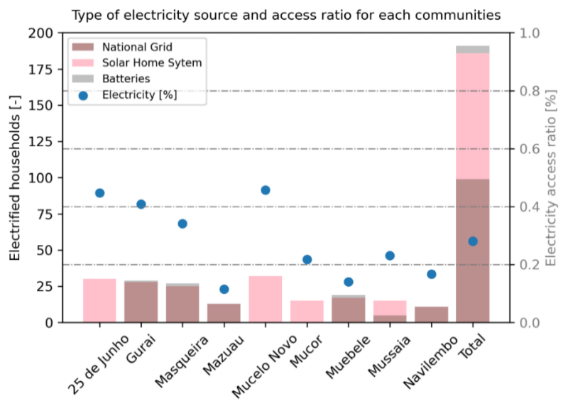

*Figure 9. Type of electricity supply for communities*

### Energy map

Finally, using the MTF approach explained previously, the author created households’ load profiles for each tier and, consequently, the load estimation of each surveyed community.

|  |  |
| --- | --- |
| *Figure 10. Load estimation of surveyed communities using MTF approach – household profile* | *Figure 11. Load estimation of surveyed communities using MTF approach – Schools and Hospitals profile* |

To spread this approach over the entire Zambezia, a preliminary classification is done. Considering indicators such as distance to the national grid, distance to the cities, number of buildings and population, three main different classes are defined: City, Sub-urban and Rural. For sake of representativeness in Figure 12 some localities are shown.

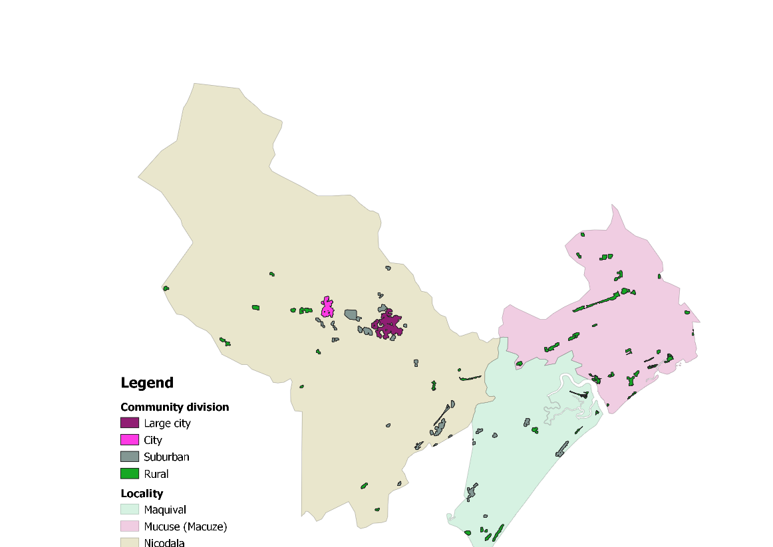

*Figure 12. Classification in City, Suburban and Rural*

As a second step, a classification in energy consumption [Wh/pp] and peak power [W/pp] classes was performed (see Table 6).

Table 5. List of surveyed communities

|  |  |  |  |
| --- | --- | --- | --- |
| Type | Classes of energy [Wh/pp] | Classes of Power  [W/pp] | Classes of Income  [kMT/pp] |
| City | 0 - 600 | 0 - 150 | 0 – 25 |
| Sub-urban | 600 - 1500 | 150 - 350 | 25 – 50 |
| Rural | >1500 | >350 | >50 |

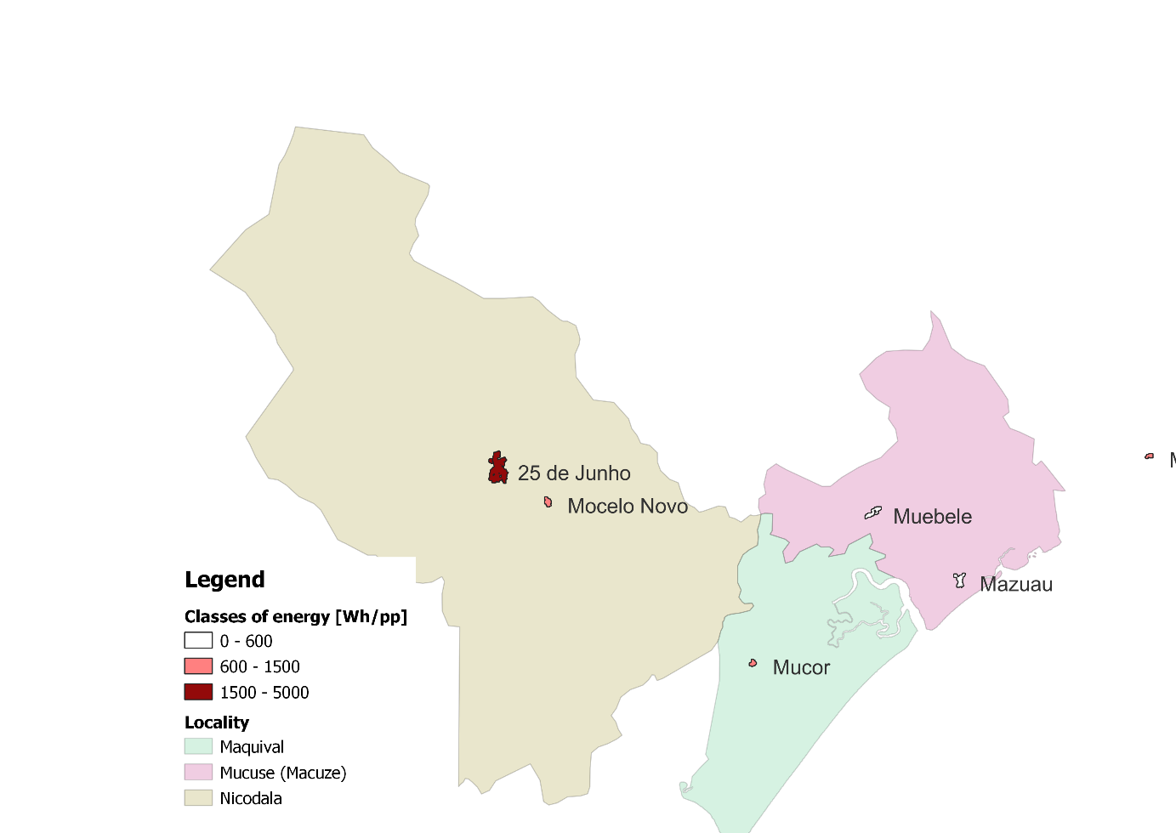

*Figure 13. Example of classification of surveyed communities based on energy classes*

Finally, knowing the correlation between loads, energy profile and cluster, as well as the number of populations, it is possible to calculate the household’s power profiles for each community. Similar information has been performed for hospitals, schools, and shops; finally, the overall load for each cluster identified in the Zambezia was computed. In Figure 14 two districts are shown, where the differences between cities and rural communities is highlighted.

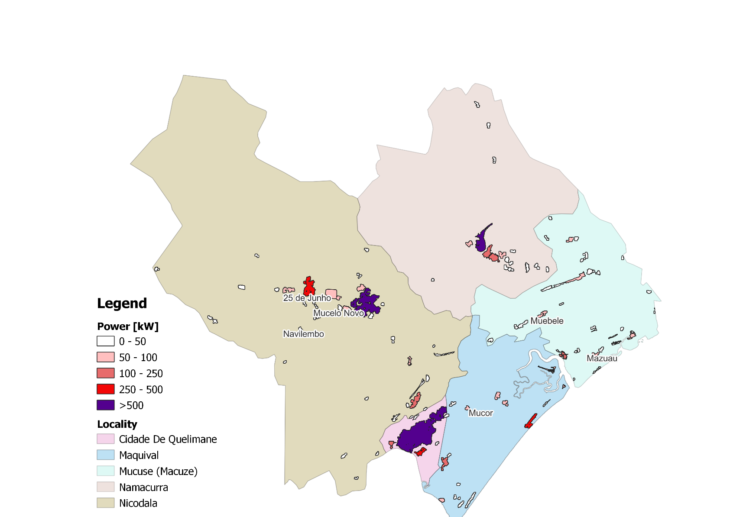

*Figure 14. Energy map of Namacurra and Nicoadala district*

## Electrification masterplan

As the final step, a preliminary routing of the national grid (for those communities’ candidate to be operated grid-tie) and the generation portfolio for microgrid (for those communities’ candidate to be operated off grid) has been performed.

|  |  |
| --- | --- |
|  | Step 1. Definition of the cluster through VANIA application. Each cluster refers to a connection point. |
|  | Step 2. Definition of connection points (i.e. for medium voltage lines) of the defined clusters. |
|  | Step 3. Deployment of MV feeders for connecting the points previously defined |
|  | Step 4. Connection to the existing national grid |
| *Figure 15. MV feeders deployment procedures* | |

The procedure, for the entire Zambezia area, evaluates the communities identified with the VANIA procedure and look for a distribution grid planning capable to feed them starting from the already in place, and from the planned, primary substations (High Voltage / Medium Voltage substations). That information has been obtained by public datasets (Figure 16). The final layout will consider all the 1292 clusters and the 11 existing substations. Then GISELe procedure is executed in order to evaluate which community could be fed by the national grid, thanks to the routing of the distribution grid, and which one is too far, i.e. is a candidate to be fed by a local microgrid; consequently the generation portfolio of such microgrid is optimized (Figure 19). The procedure is based on a genetic algorithm and consider the geographical parameters of the area (land types and potential obstacles, roads – in particular, lines are supposed to be cheaper if deployed along the path of an already existing road). A detailed description of the algorithm adopted is available in Figure 15. Figure 17 reports the routing of the proposed MV grid devoted to connecting the communities viable for being fed by the national grid. Finally, Figure 18, the communities’ candidates to be operated off-grid are depicted in black. Finally, considering a maximum acceptable distance to substation, the authors defined the clusters that should be electrified with off-grid systems. Based on this classification, a proposal for installing new substations is developed. The placement of these substations is carefully determined to minimize transmission losses, improve grid reliability, and ensure equitable access to electricity. The integration of various tools and methodologies presented in this chapter demonstrates the comprehensive approach to optimizing electrification planning in Zambezia.

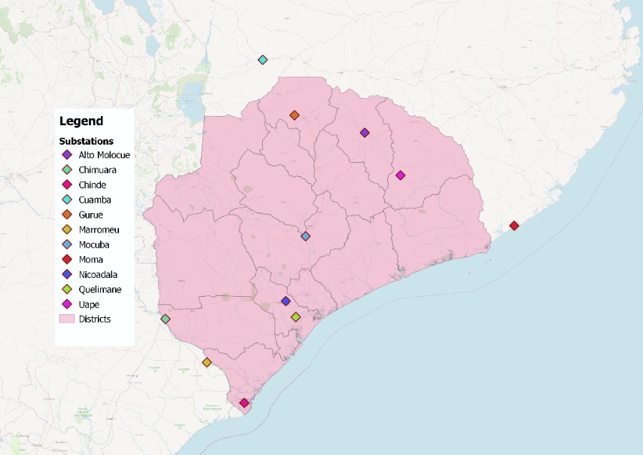

*Figure 16. Zambezia Area and already in place, or planned, HV/MV substations (i.e. connections among distribution grids and the national grid)*

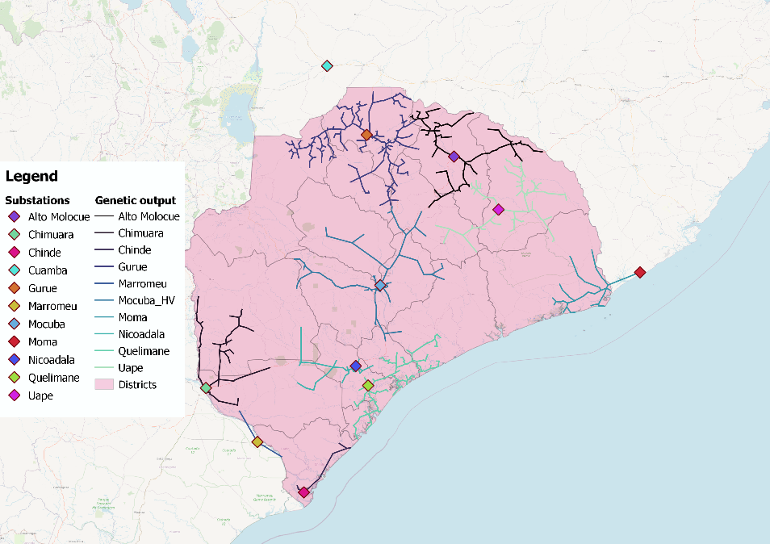

*Figure 17. Distribution grid routing connecting the identified communities with the HV/MV substations*

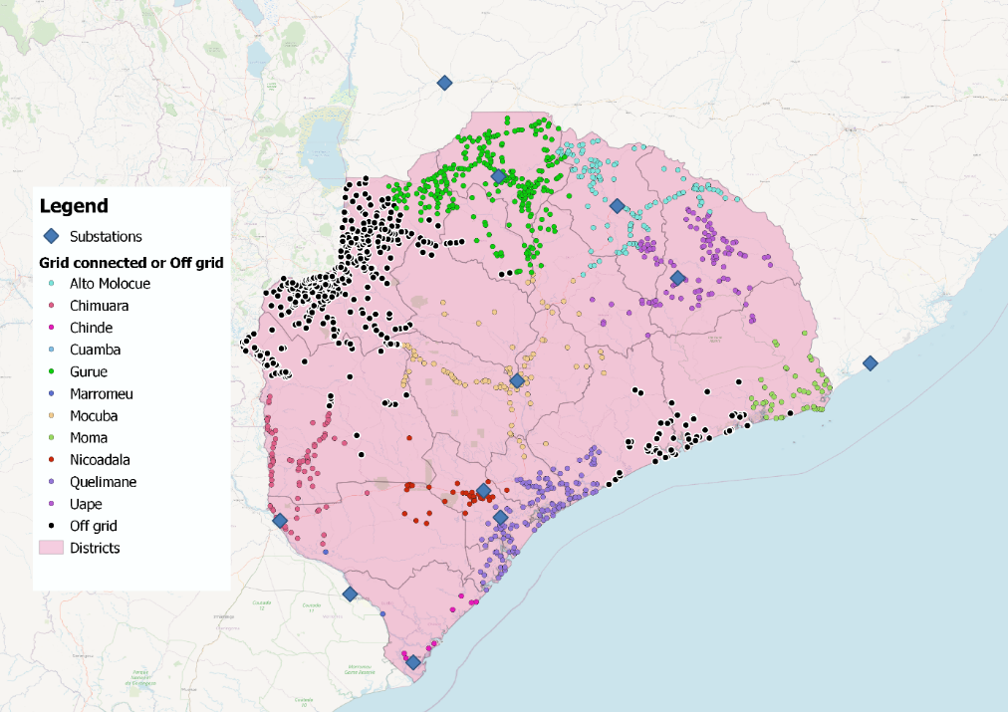

*Figure 18. Total set of communities processed in the Zambezia area, the coloured one are candidate to be operated grid-tie, the black ones are candidates to be operated stand-alone*

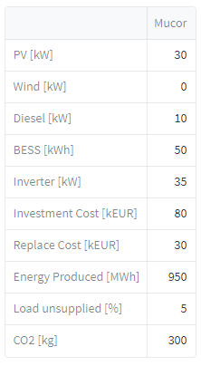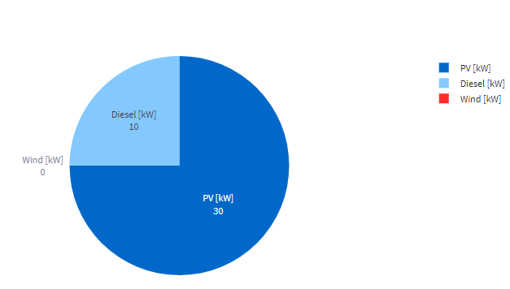

*Figure 19. Example of a generation portfolio optimization for one of the investigated clusters (i.e. for one microgrid candidate to be operated stand-alone)*

# Future improvement and Follow-ups

The present chapter briefly presents proposals for improvements and possible follow-ups.

* The calculation of the loads for the main economic activities within the region is based on weak hypothesis. The lack of data and difficulties to gather information leave this chapter open for next follow-ups. Particularly, together with ICEI a data acquisition campaign has started in order to better define the requirements of such sectors. Equally, the shops and other commercial activities must be addressed to better define the factors used.
* One of the main criticalities that have been faced during the project is the inconsistency between opensource datasets. The authors strongly believe in the powerful mean of open-source data but with reliable datasets. Indeed, Governments, development partners, and private sector actors need to invest in data collection mechanisms, including surveys and energy audits, to collect accurate and reliable data on the energy sector.
* Finally, the next steps would require the improvement of the energy map, for each community, with the layers listed below.

# Annex 1 - Acronyms

|  |  |
| --- | --- |
| ICEI | Istituto Cooperazione Economica Internazionale |
| SDG | Sustainable Development Goals |
| GISELe | GIS for rural electrification |
| VANIA | Village ANalytics In Africa |
| E4G | Energy For Growing |
| MTF | Multi-Tier Framework |
| WHO | World Health Organization |
| TERESA | TEchnology for Rural Electrification in Sub-Saharan Africa |
| JICA | Japanese international cooperation agency |
| HSDP | Health Sector Development Plan |

# Annex 2 - User Friendly Dashboard

Finally, an open-source user-friendly tool has been developed to make the visualization of the data easy. This chapter will briefly present the main features and the structure of the tool. In the tool home page there is a description of the main objective and a small presentation of the partners. Moreover, the contacts of the research group can be found at the end of the homepage. On the right side of the screen there is the possibility to choose the page for navigation. In particular:

1. Surveyed refers to all the information related to the surveyed communities, with the data from the surveys, the main outcomes from the postprocessing and other useful information to better define the communities.

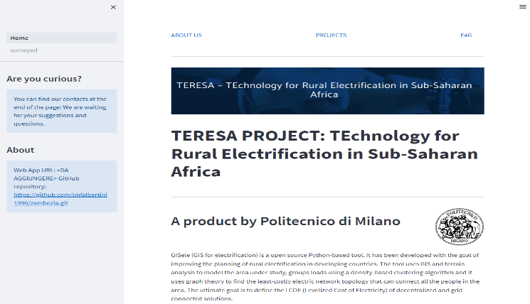

1. Electrification procedure: the final energy density map of Zambezia and the final results related to the generation portfolio and the electric network deployment is displayed.

It is also possible to download the pdf version of the report as shown below.

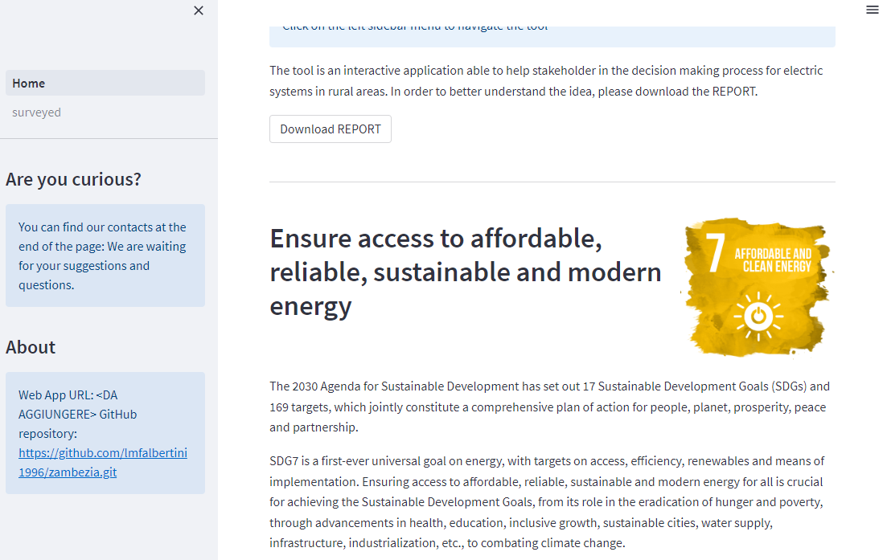

## Surveyed

### Surveyed: Entire Area

On the right bar, selecting *entire area*, it is possible to analyze the overall studied area with the surveyed communities.

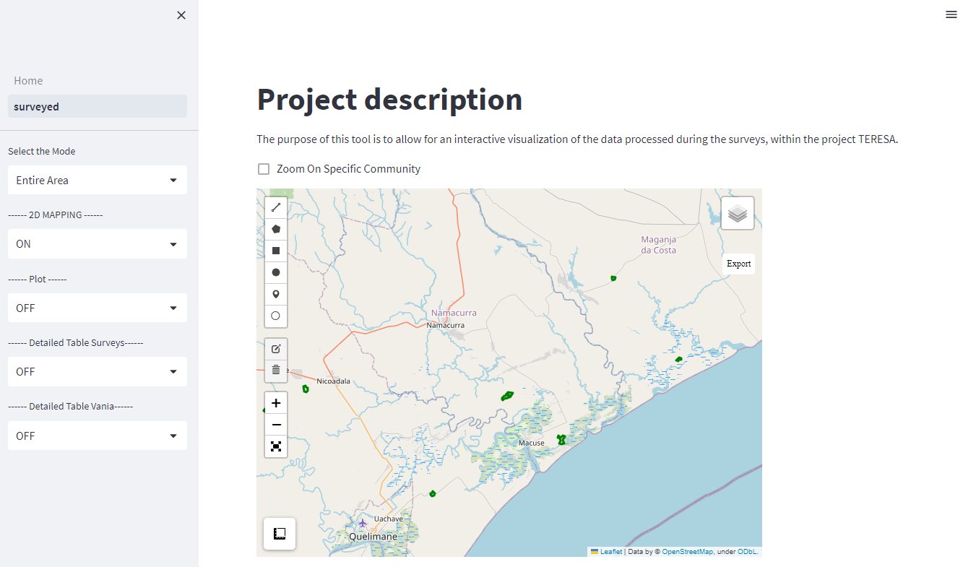

Particularly, clicking on *layers image* on the up-right corner, it is possible to display all the information related to the selected cluster.

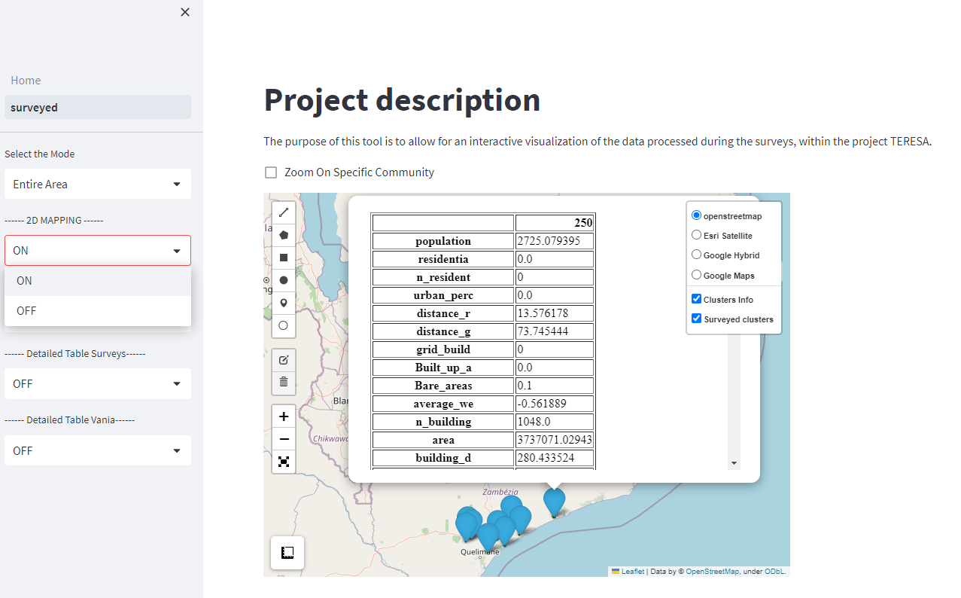

For a more specific and rapid description of parameters, selecting different plots on the left bar is possible to have further info. Once set the type of plots, it is possible to choose between several variables and correlations.

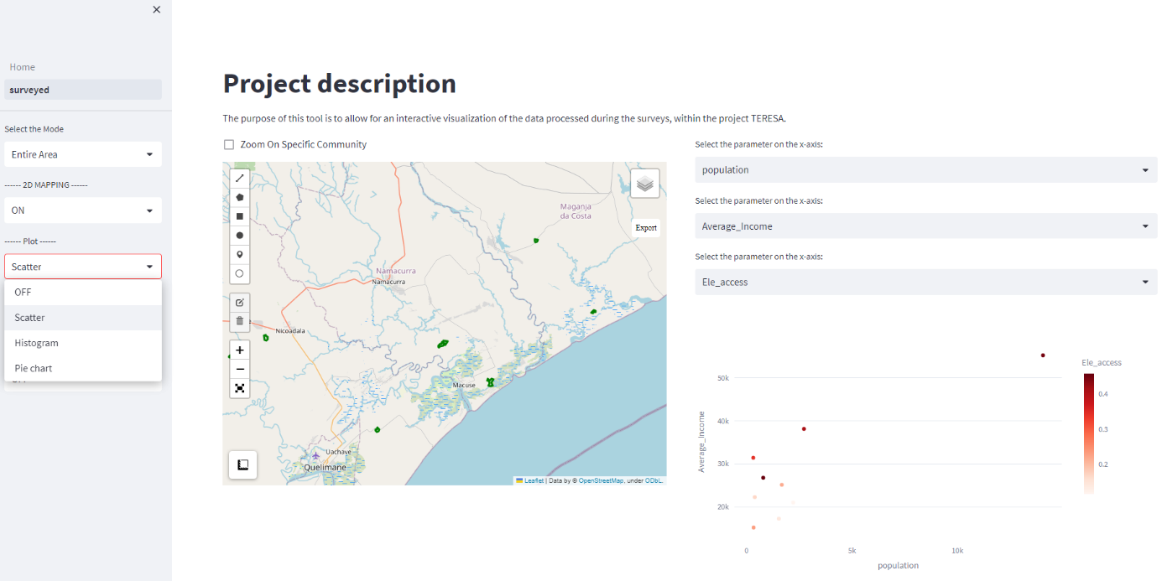

Finally, always in the right bar, it is possible to select the tables with numerical results from the surveys and the VANIA tool.

The GUI will display the entire tables with the overall variables.

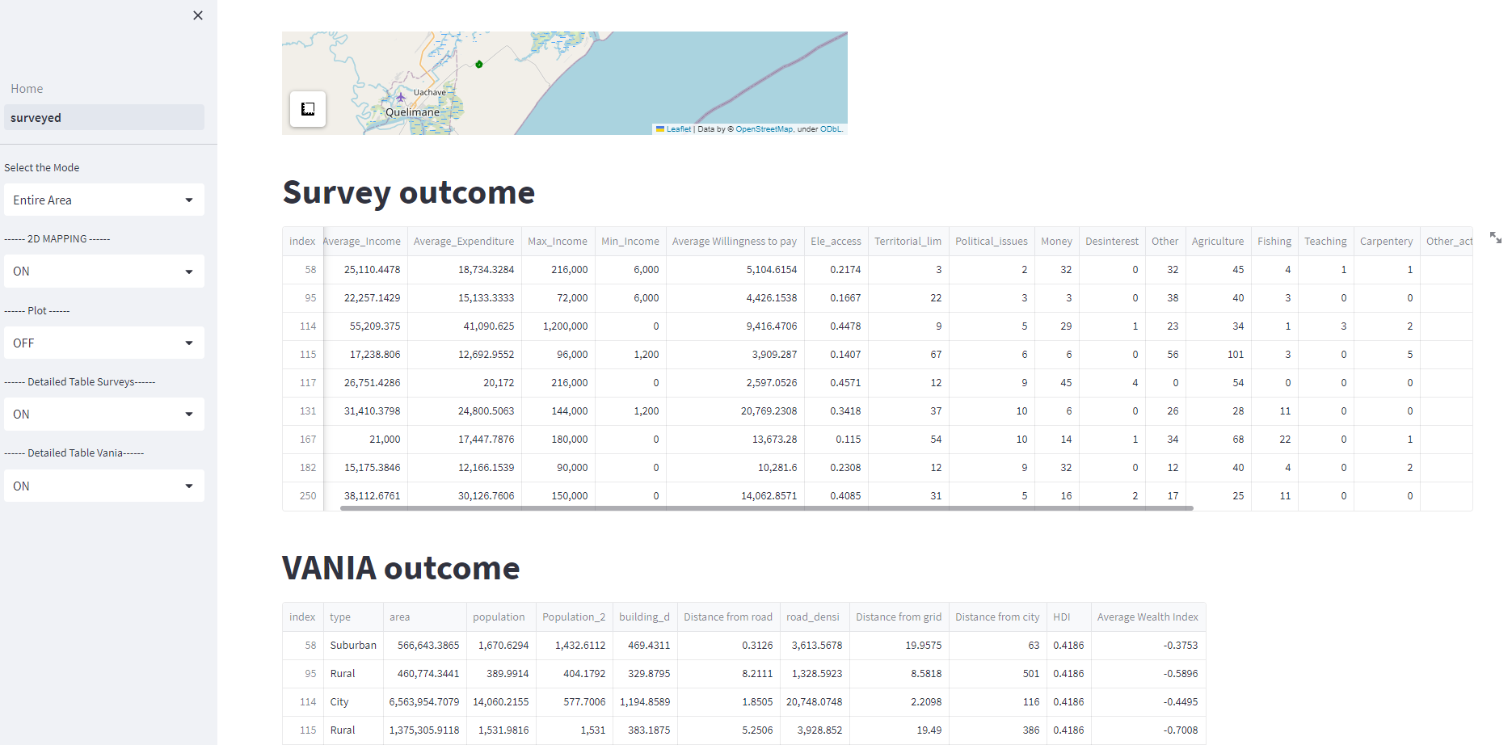

### Surveyed: Single Cluster

In this section, a deeper analysis of each cluster is possible through the comparison with the other clusters. Indeed, the daily energy load profile and other requirements are displayed. Moreover, in this section the preliminary analysis displaying the generation portfolio and the outcome of the microgrid optimization is reported. All the communities are displayed with the 2D map and the description with the primary information.

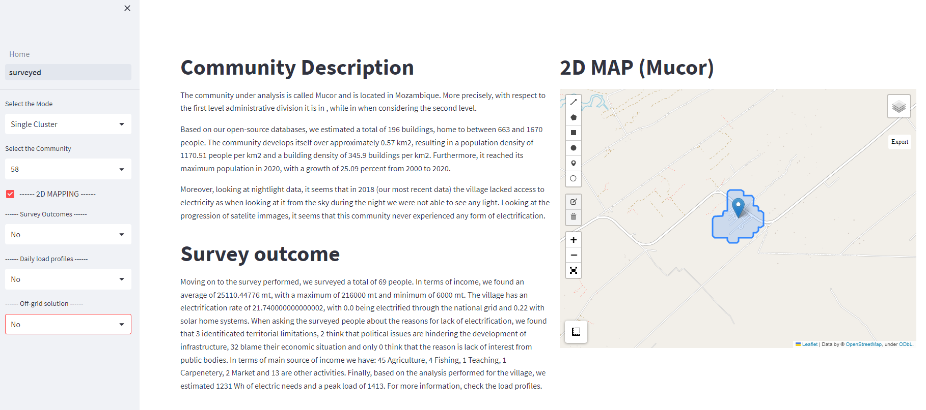

Selecting *survey outcomes*, it is possible to choose between different parameters. The pie-chart will be displayed, and the chosen community is compared in a bar plot with the others.

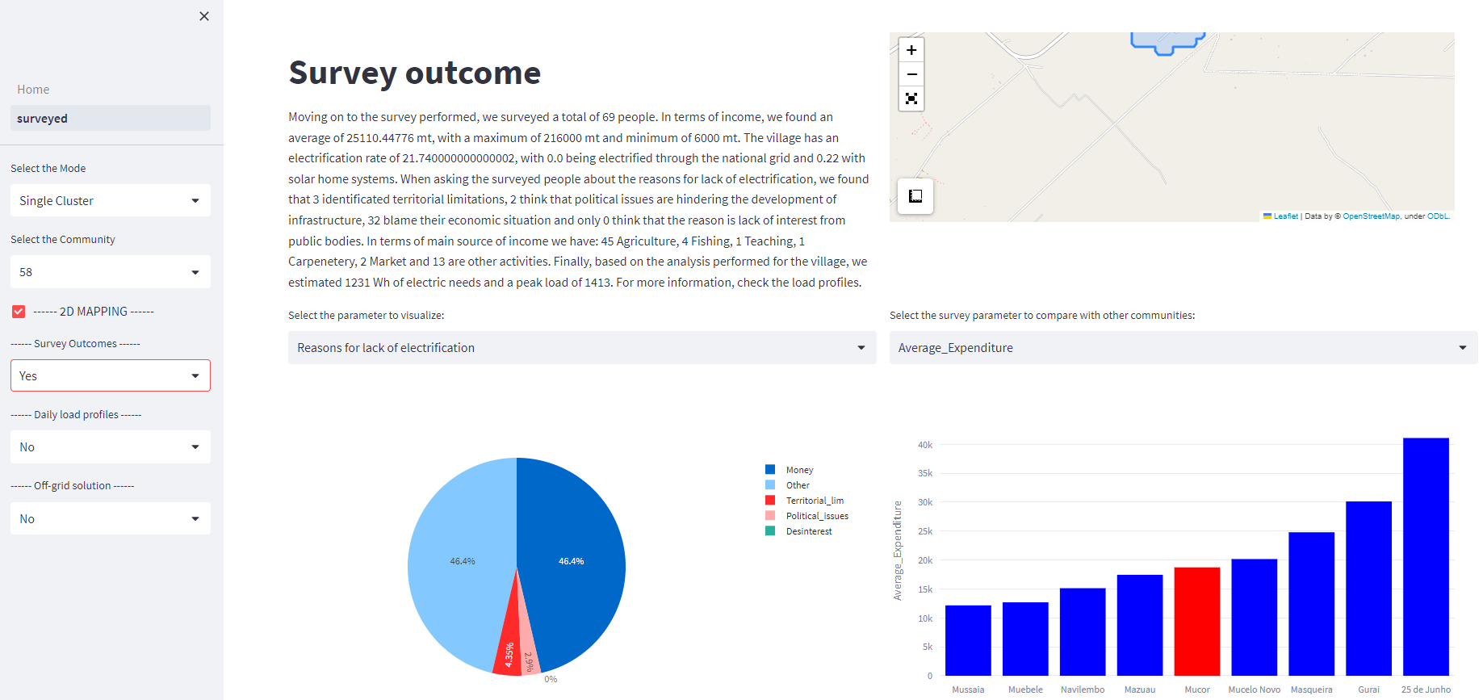

Selecting *daily load profile*, the energy demand calculated as explained in the report is shown.

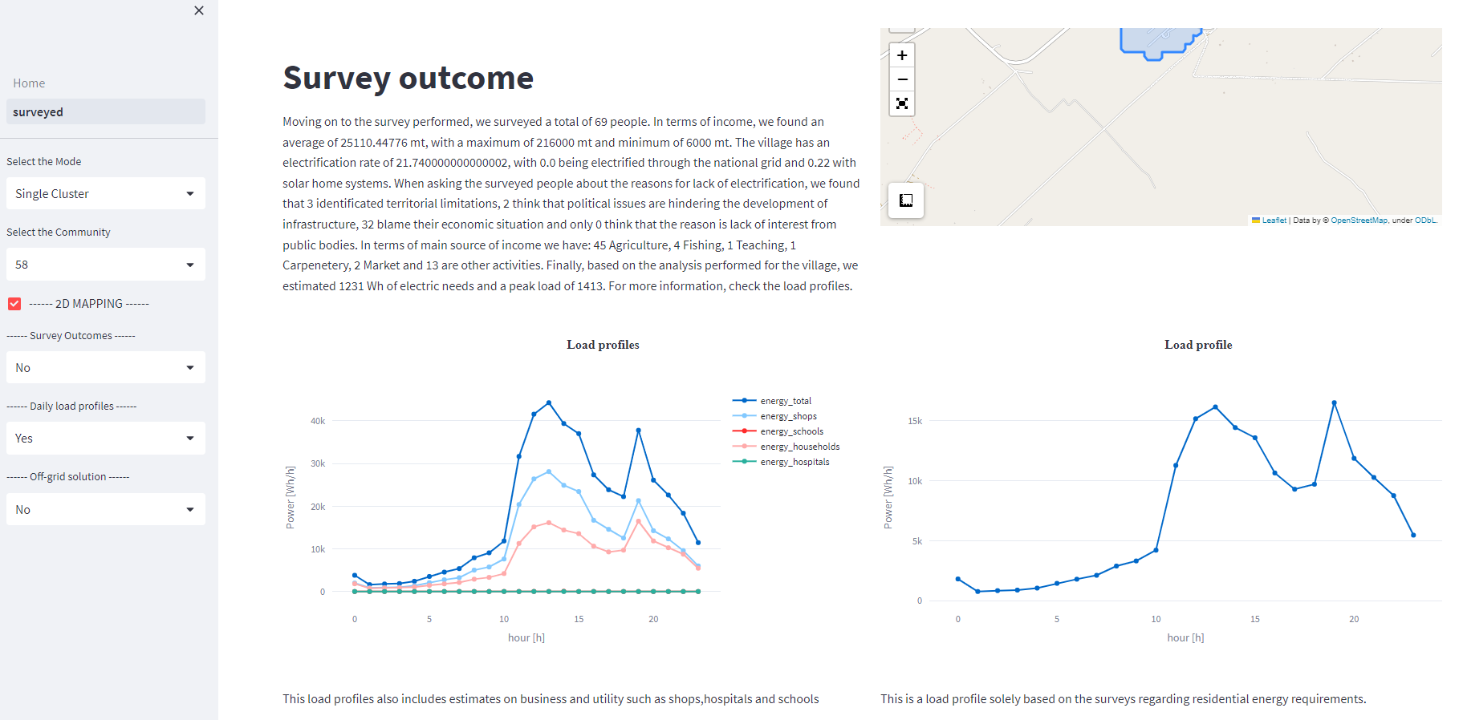

Finally, the output of the Off-grid solution can be displayed.

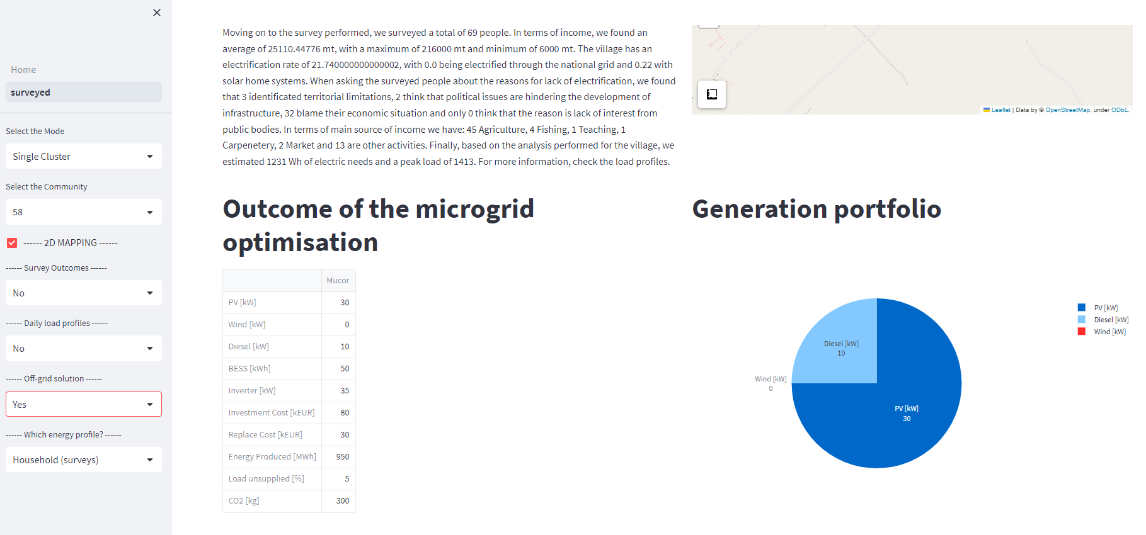

The *single cluster* option reports data coherently with the criteria already detailed for the previous cases.

### Surveyed: Compare clusters

In the last section of surveyed pages, the user can compare two clusters through pie-charts various indicators and compare the two-chosen one with all the others thanks to a bar plot.

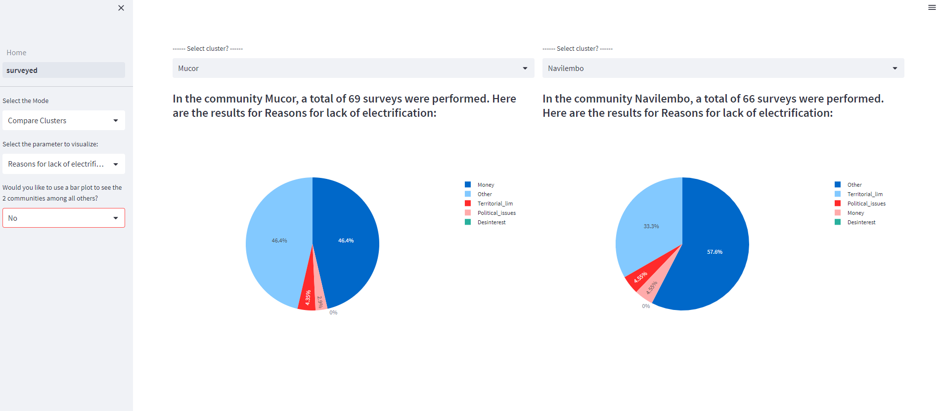

## Zambezia visualization

### Zambezia visualization: Entire area

In this page, the entire Zambezia and all the defined clusters are displayed and analysed. Indeed, the energy map, the preliminary analysis of the national grid and the output of the microgrid system are displayed for the user. Started analyzing the entire area, the user is able to create plot in order to better define all the clusters and to see the clusters in a 2D map. Selecting *Histograms*, the tool displays a specific information of the clusters in different histogram plots.

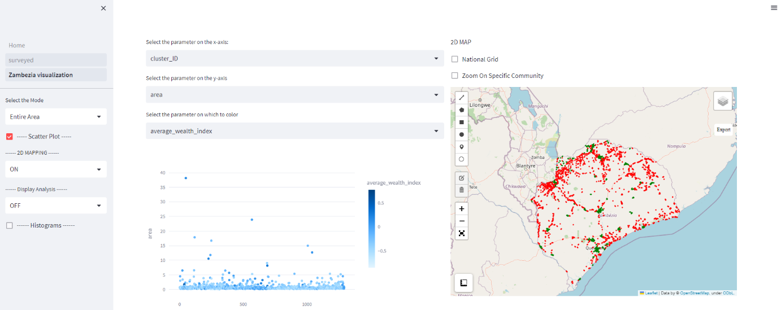

In the 2D map, in red are displayed the non-electrified communities and in green the electrified ones. Moreover, selecting the analysis, the structure of the national grid is shown. In particular, in black are reported all the communities that, according to the performed simulations, should be electrified through off-grid systems.

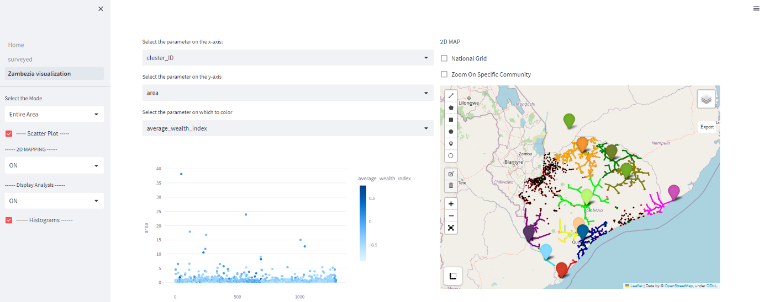

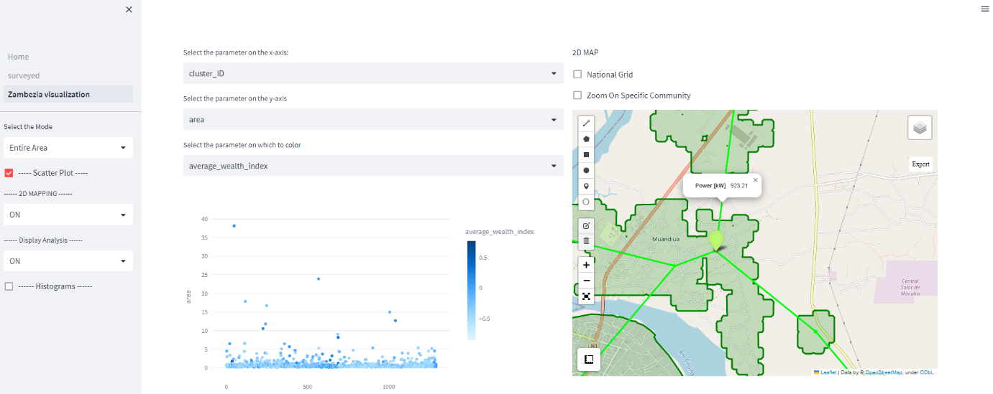The different colors of the electric network refer to the different substation at which the lines refer to. Clicking on the icon of the layers on the up-right corner, it is possible to select or deselect all the lines of each substation. Finally, zooming on the 2D plot the user is able to see the main characteristics of the lines (i.e. power flow).

1. Li, X., Zhou, Y., Zhao, M., Zhao, X., 2020. A harmonized global nighttime light dataset 1992–2018. Scientific Data 7, 168. https://doi.org/10.1038/s41597-020-0510-y